
Govt. of Bihar
MUZAFFARPUR INSTITUTE OF TECHNOLOGY,
MUZAFFARPUR, BIHAR – 842003
(Under the department of Science &Technology, Bihar, Patna)

B. Tech. 5th Semester Mid-Term Examination Answers, 2018
ADVANCE SURVEYING
Time: 2 hours Full Marks: 20
Subject Code: 011524
Attempt any four questions.

- Write the procedure for setting out of simple curve by Rankine’s method with neat diagram and formulations.
Answer:-
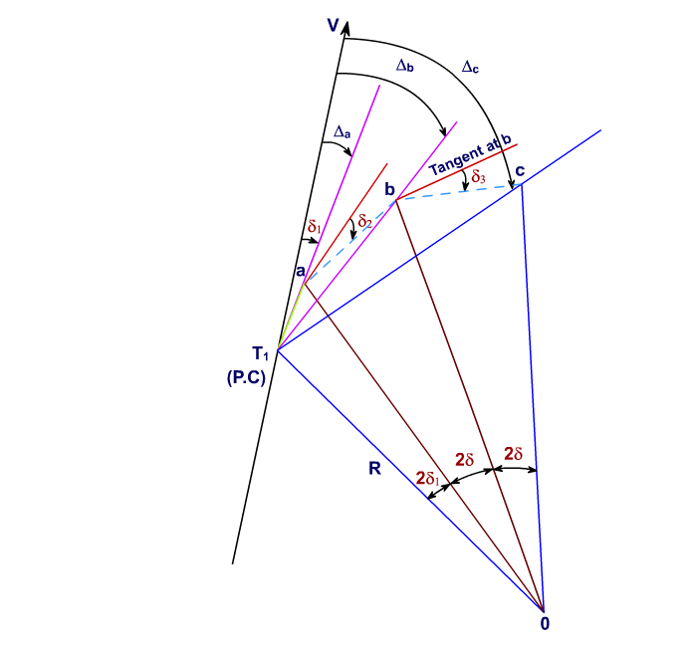
Following are the steps for setting out of simple curve by Rankine’s Method:
- A theodolite is set up at the point of curvature T1, and get it temporary adjusted.
- The vernier A is set to zero, and get the upper plate clamped. After opening the lower plate main screw, sight the point of intersection, V. Then the lower plate main screw gets tightened and get the point V bisected exactly using the lower plate tangent screw. Now the line of sight is in the direction of the rear tangent T1 V and the vernier A reads zero.
- Open the upper plate main screw, and set the vernier A to the deflection angle Da. The line of sight is now directed along the chord T1 a. Clamp the upper plate. 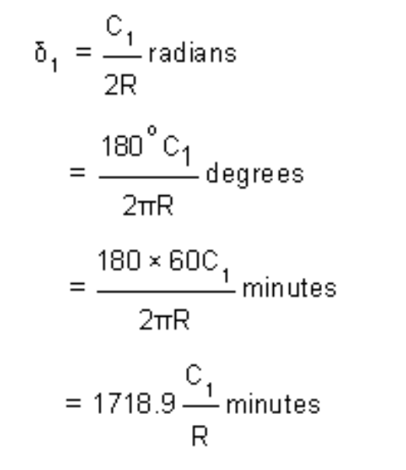
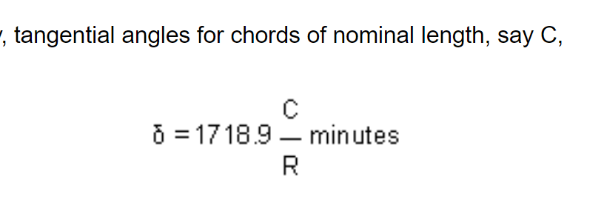
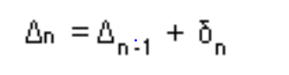
- Hold the zero end of the tape of a steel tape at T1. Note a mark equal to the first chord length C1 on the tape and swing an arrow pointed at the mark around ‘a' till it is bisected along the line of sight. The arrow point then indicates the position of the first peg ‘a'. Fix the first peg at ‘a'.
- Unclamp the upper plate, and set the vernier A to the deflection angle Db. The line of sight is now directed along T1 b.
- With the zero end of the tape at a, and an arrow at a mark on the tape equal to the normal chord length C, swing the tape around b until the arrow is bisected along the line of sight. Fix the second peg at the point b at the arrow point.It may be noted that the deflection angles are measured from the tangent point T1 but the chord lengths are measured from the preceding point. thus, deflection angles observed are cumulative in nature but chord lengths swung are individual in nature.
- Repeat steps (5) and (6) till the last point is reached. The last point so located must coincide with the tangent point T2 already fixed from the point of intersection.

- Two straights AB and BC is intersecting at a point B having bearings BA =270 degree, BC 110 degree,. They are to joined by a circular curve which must pass through a point D which is 150m from B and bearing of BD =190 degree. Find the required radius, length of the curve and tangent lengths.
Answer:-
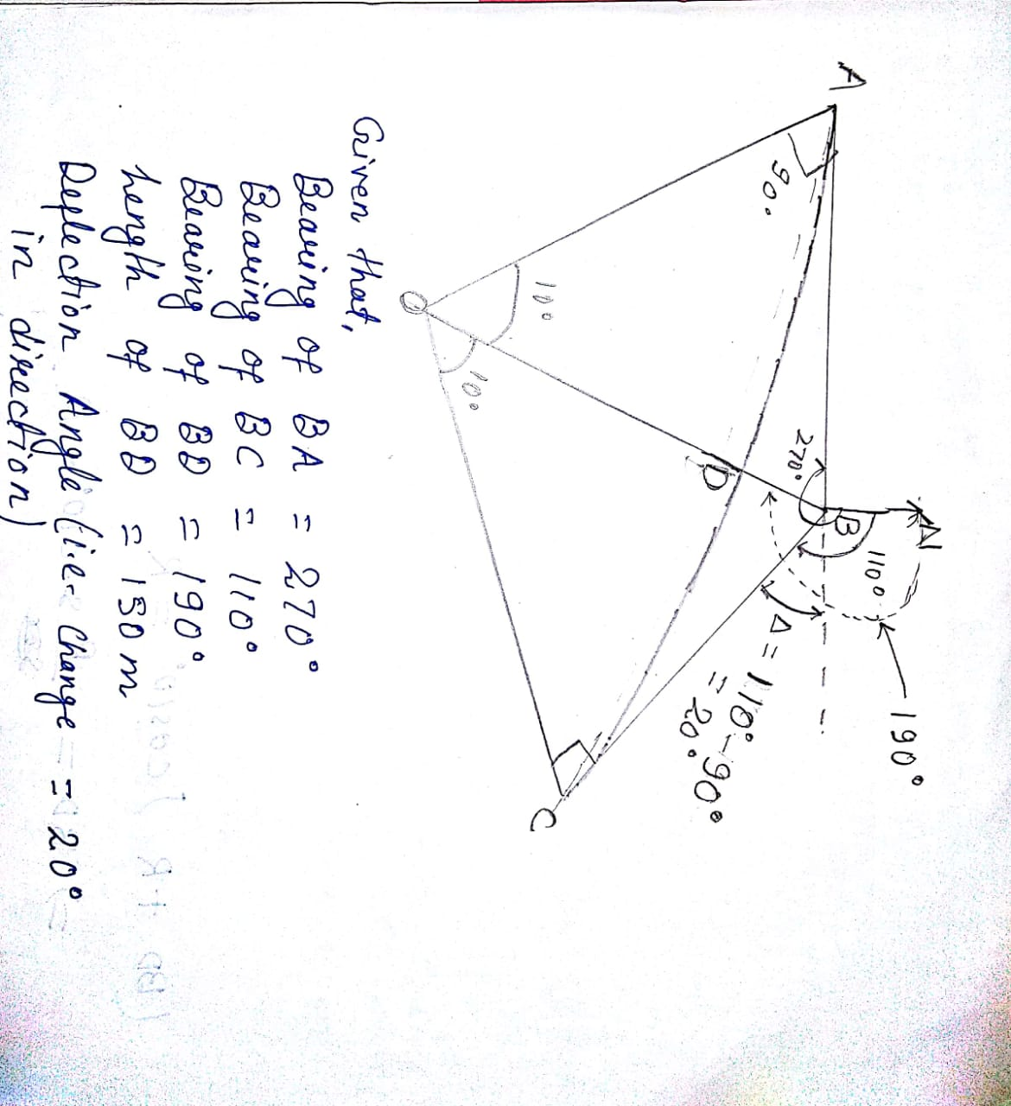
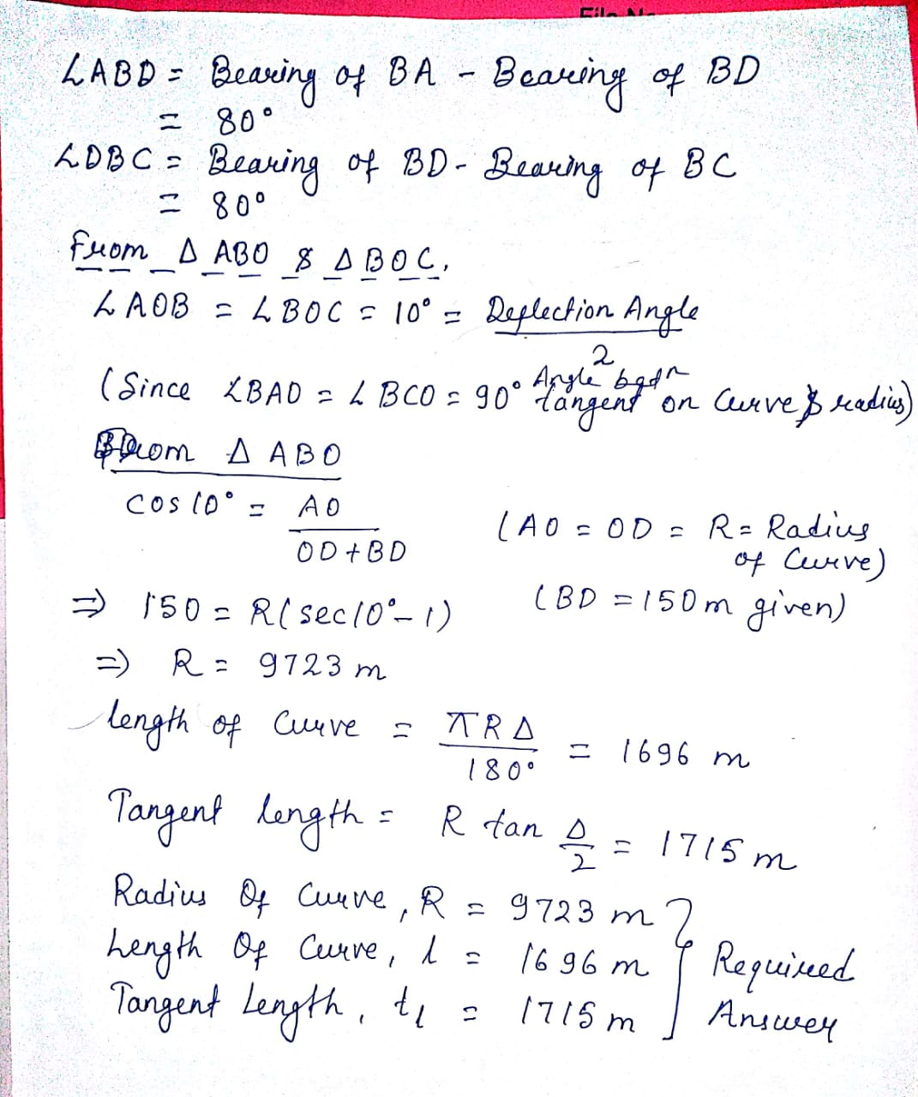

- a) What do you mean by Compound and Combined Curve ?
Answer: A compound curve is a combination of two or more simple curves with different radii. The two centred compound curve has two circular arcs of different radii that deviate in the same direction and join at a common tangent point.
A curve consisting of transition curve and simple or combined curve is known as combined curve. For practical purposes combined curve is required for easiness and safe of movement of traffic intending to change in directions between two straights.
(b) A 3% downgrade curve is followed by a 1% upgrade curve and rate of change of grade adopted is 0.1% per 20m length. Find the length of vertical curve.
Answer :
Total Change in gradient = (-3 %)-(= 1 %) =-4 %
Length of Curve = Total Change in gradient/ rate of change of grade =800 m.

- During the reconnaissance of a hilly part of the country for geodetic surveying, the following data were obtained regarding the profile of intervening ground between stations P and Q, the distance PQ being 120km. Peak L and M are situated in the line PQ such that PL= 50km and PM= 80km. The elevations above mean sea level are P=210m, Q= 1050m, L=330m and M=557m. Determine whether P and Q are intervisible, and if necessary, find the minimum height of the scaffolding at Q, assuming P as the ground station. The line of sight should clear the intervening peaks at least 3m.
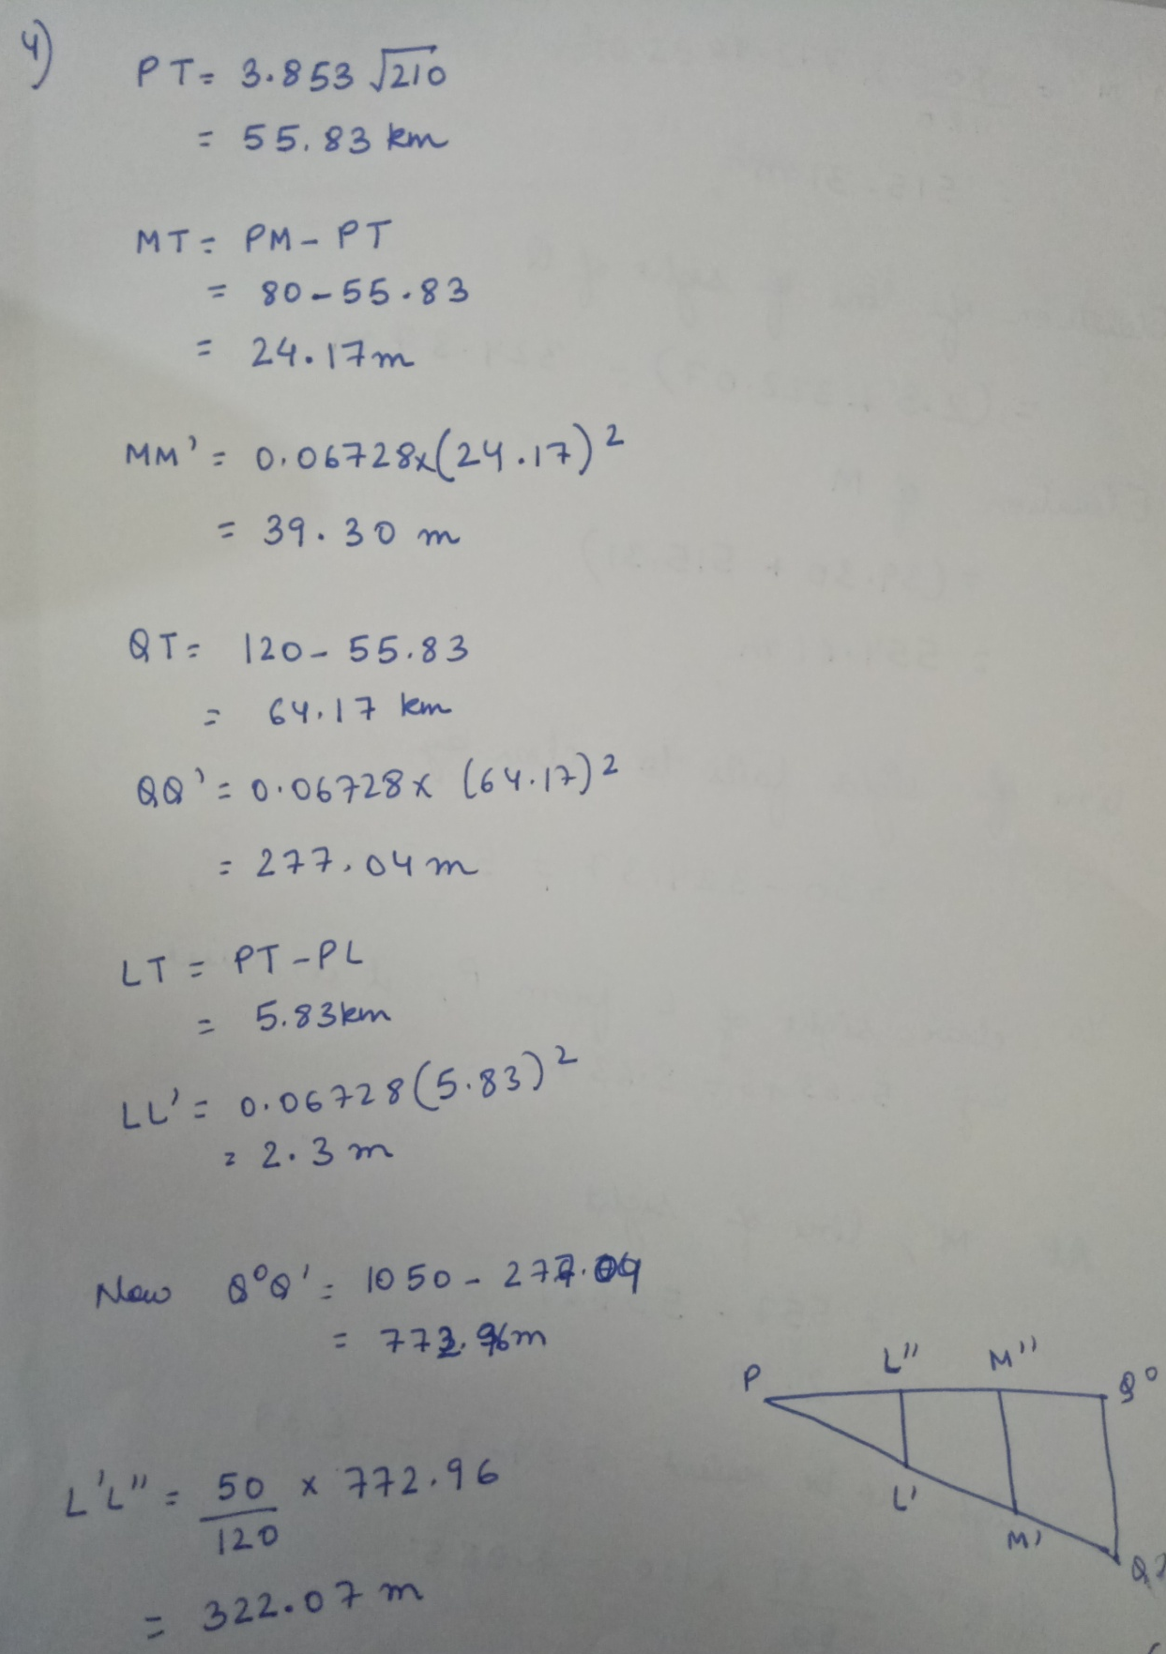
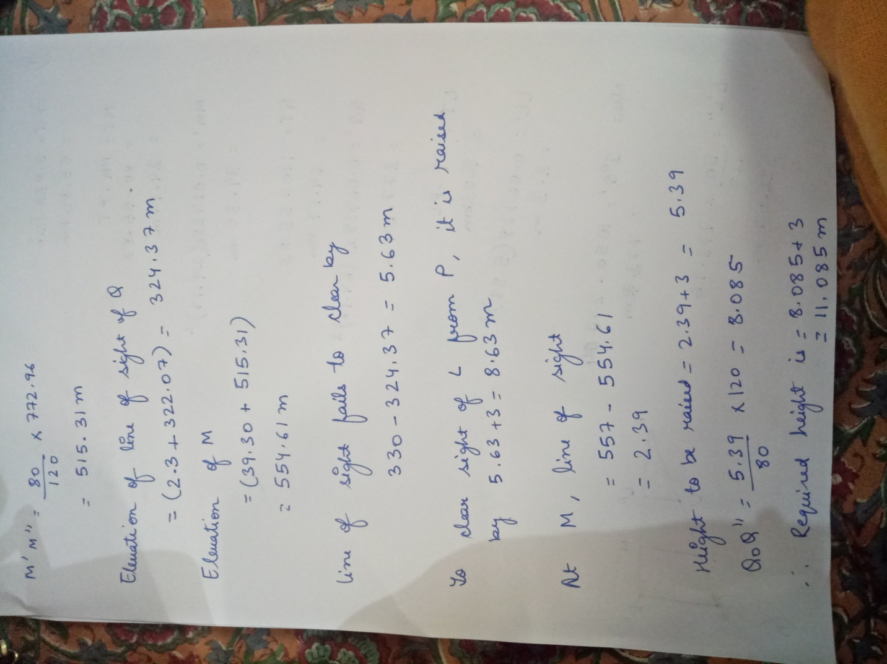

- A) What is a satellite station?
To secure well conditioned triangles or to have intervisibility, objects having high elevation are selected as triangulation stations. In certain cases, it is not possible to occupy the station directly below the selected stations.
To solve this problem another station in the vicinity of the point where instrument can be set up and from where all the three points are visible. Such a station is known as a satellite station.
B) A, B and C are the stations in a minor triangulation survey. A satellite station S is set up near C such that AC and BC fall within triangle ASB. It is given that AC= 7.5km, BC= 6.3km, CS=40.5km, angles ASC= 62°10’40” and ASB= 75°15’15”. Calculate angle ACB.
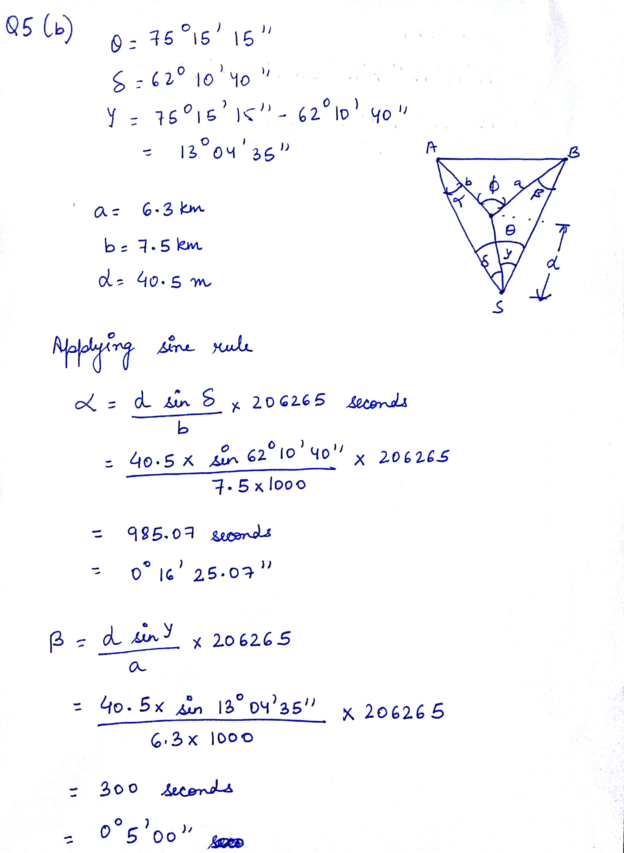
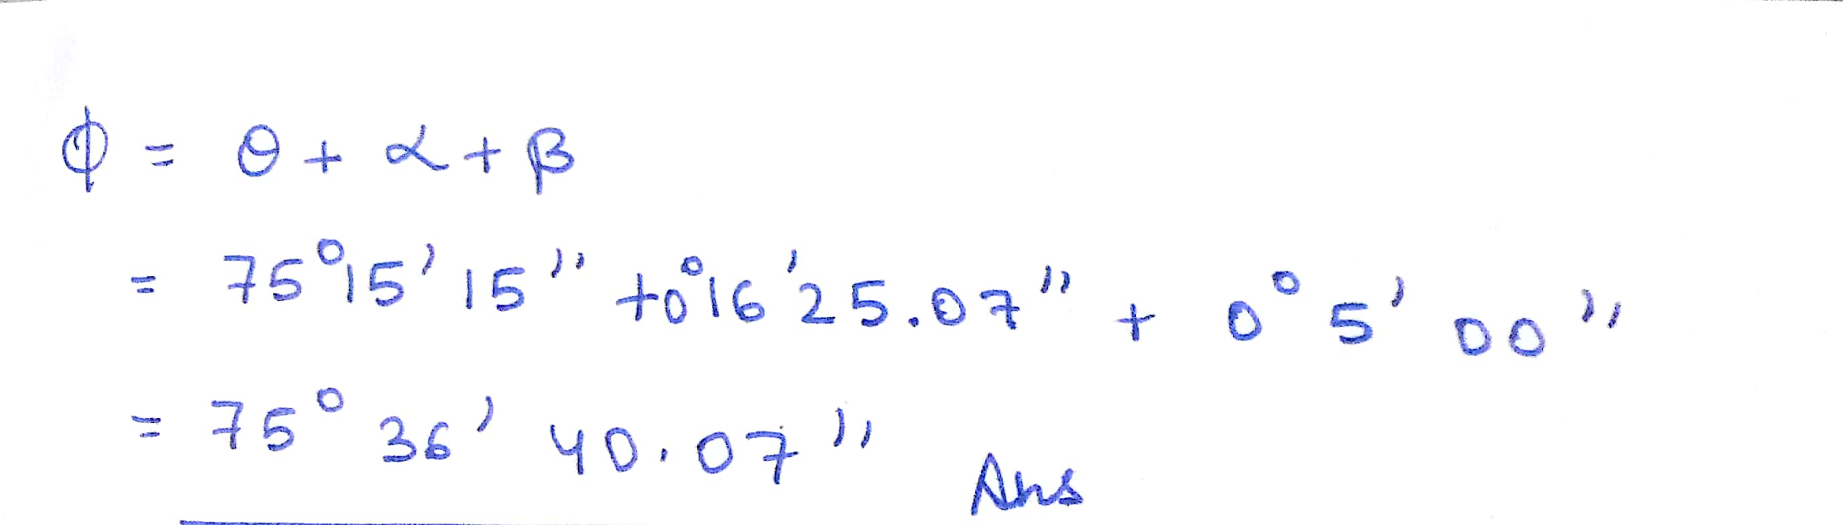
- A) What do you understand by hydrographic surveying? What are its common uses?
A survey conducted to gather information about the physical features of a water body is known as hydrographic survey.
Applictations:
  - Measurement of tides
  - Determination of bed depths
  - Determination of scouring, silting
  - Determination of shore lines
  - Establishment of mean sea level
  - Measurement of discharge of rivers and streams., etc.
B) What are the various operations performed by total station? Enlist the advantages of using total station over conventional surveying equipments.
Operations:
  - Measurement of vertical angles.
  - Measurement of horizontal angles.
  - Measurement of vertical distance.
  - Measurement of horizontal distance.
  - All the 3 coordinates of a point
Advantages:
  - Better accuracy
  - Less time consuming
  - No need to note down the values
  - Less human error
  - Can work day and night, etc.

BEST OF LUCK

