
Govt. of Bihar
MUZAFFARPUR INSTITUTE OF TECHNOLOGY,
MUZAFFARPUR, BIHAR – 842003
(Under the department of Science &Technology, Bihar, Patna)

B. Tech. 7th Semester Mid-Term Examination, 2018
TRANSPORTATION ENGINEERING-II SOLUTIONS
Subject Code: 011X24

- The side slopes of embankments for a railway track is generally taken as:
(i) 1:1 (ii) 1.5:1 (iii) 2:1 (iv) 1:2
- For a broad gauge route with M+7 sleeper density, number of sleepers per rail length is:
(i) 18 (ii) 19 (iii) 20 (iv) 21
- The shape of transition curve used by Indian railway :
(i) Cubic parabola (ii) spiral (iii) sine curve (iv) lemniscates of Bernoulli
- Distance between inner faces of the flanges is kept
(i) Equal to the gauge distance (ii) slightly less than the gauge distance (iii) slightly more than the gauge distance (iv) none of these
- The railway has ………….. degree of freedom for its movement.
(i) one (ii) two (iii) three (iv) four
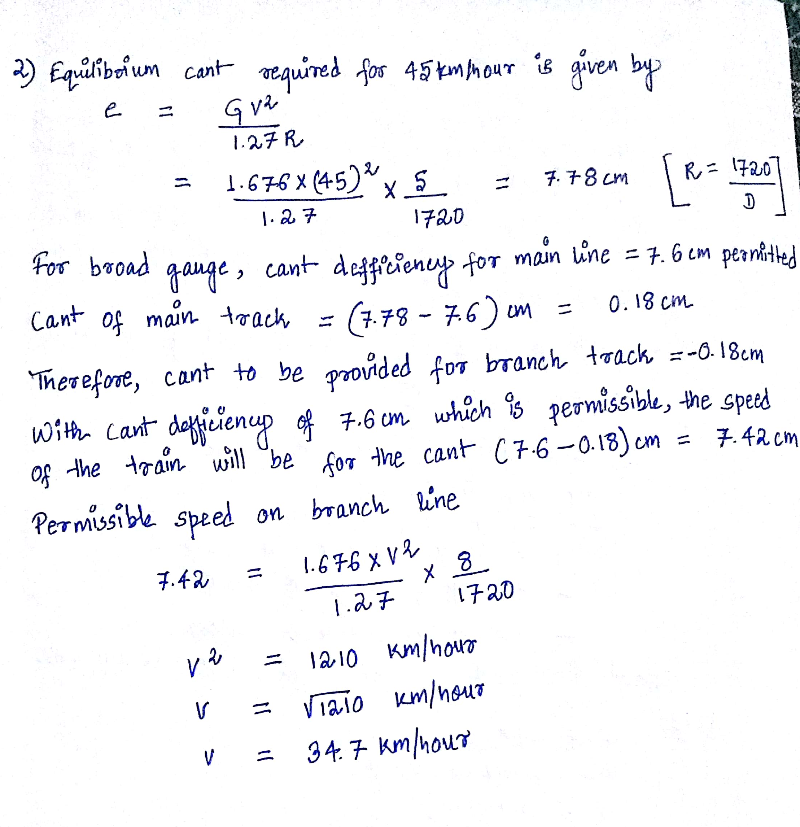
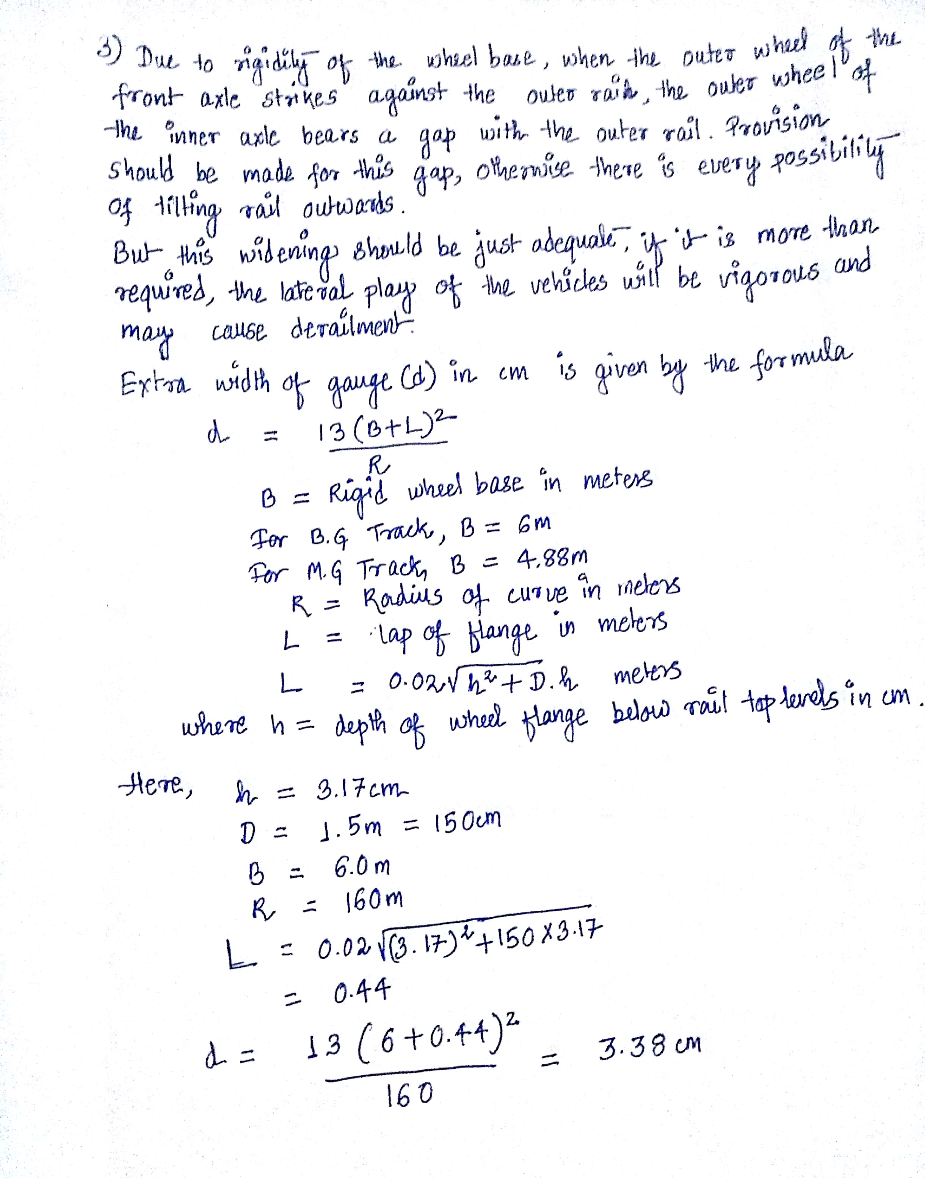

- Outer Signal: The outer is the first ‘stop’ signal at a station where it is provided i.e., this is the first stop signal which indicates the entry of the train from block to the station yard. It should be placed at an adequate distance from the point upto which the line can be constructed after permission to approach has already been given. This adequate distance on the basis of maximum allowable speed in India comes equal to 0.54 km for B.G. and 0.40 km for M.G.
Home Signal: Due to its location at the door of station, it is termed as home signal. The home-signal has bracketed arms to indicate which line is to be used. It is one of the important functions of interlocking to ensure that the route is properly set before the signal arm is taken to “OFF” position. So the function of Home signal is to protect the sidings already occupied. This signal is, therefore, located not more than 180 meters from the start of points or switches and unless there are other means of holding the route. Lock retaining bars are provided to hold the route when the distance is more than 180 meters.
Starter Signal: Starter signal marks the limit upto which trains stopping at a station come to stand or halt. Home signals carry as many arms as the number of diverging lines whereas separate starting signal is provided for each line. The starter is the last stop signal at a station. No train can leave the station unless the starter signal shows the ‘Proceed’ position.
Advance starter: Besides the starter signal for each of the station lines from which trains start, an advance starter may also be provided beyond the trailing points or switches. In general, advance starter is an indication for the train having left the station and is no more the responsibility of the station master.
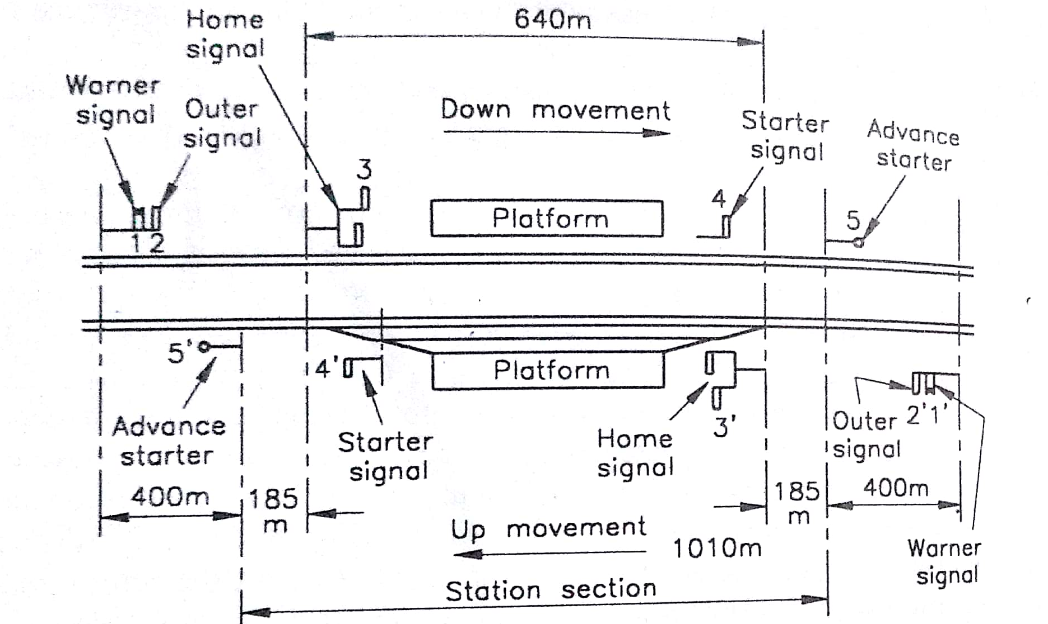
Figure: Signals in station yard

- (a) Coning of wheels: The distance between the inside edges of the flanges is generally kept less than the gauge of the track. So, there is a gap between wheel flanges and running edges of the rails, nearly equal to 1cm on each side. Normally, the tread of wheel is absolutely dead centre of the head of the rail, as the wheel is coned to keep it in this central position automatically. These wheels are coned at a slope of 1 in 20.
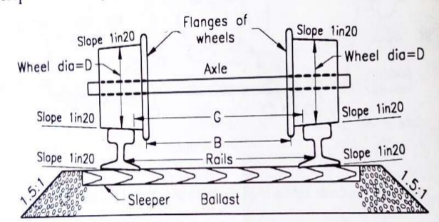
Figure: Coning of Wheels
(b) Grade compensation on curves: The ruling gradient is the maximum gradient on a particular section, but if a curve lies on ruling gradient, the resistance due to gradient is increased by that due to curvature and this further increases the resistance beyond ruling gradient. In order to avoid resistances beyond allowable limits, the gradients are reduced on curves and this reduction in gradient is known as grade compensation.
In India, compensation for curvature is given at 0.04% per degree of curvature for B.G., 0.03% for M.G. and 0.02% for N.G.
(c) Minimum Depth of Ballast: Although the lines of equal pressure in ballast through wheel loads are in the shape of a ‘bulb’ yet for simplicity purpose, the load dispersion can be assumed at 45° to the vertical. For uniform distribution of load on the formation, the depth of ballast should be such that the dispersion lines do not overlap each other. From simple geometry, the depth of ballast can be calculated as:
Sleeper Spacing (s) = width of sleeper (w) + 2* depth of ballast (D_{b})
