Solution of Mid-Term Examination, 2018-19

**Organizational Behaviour and Industrial Psychology (24 101)**

**1.**

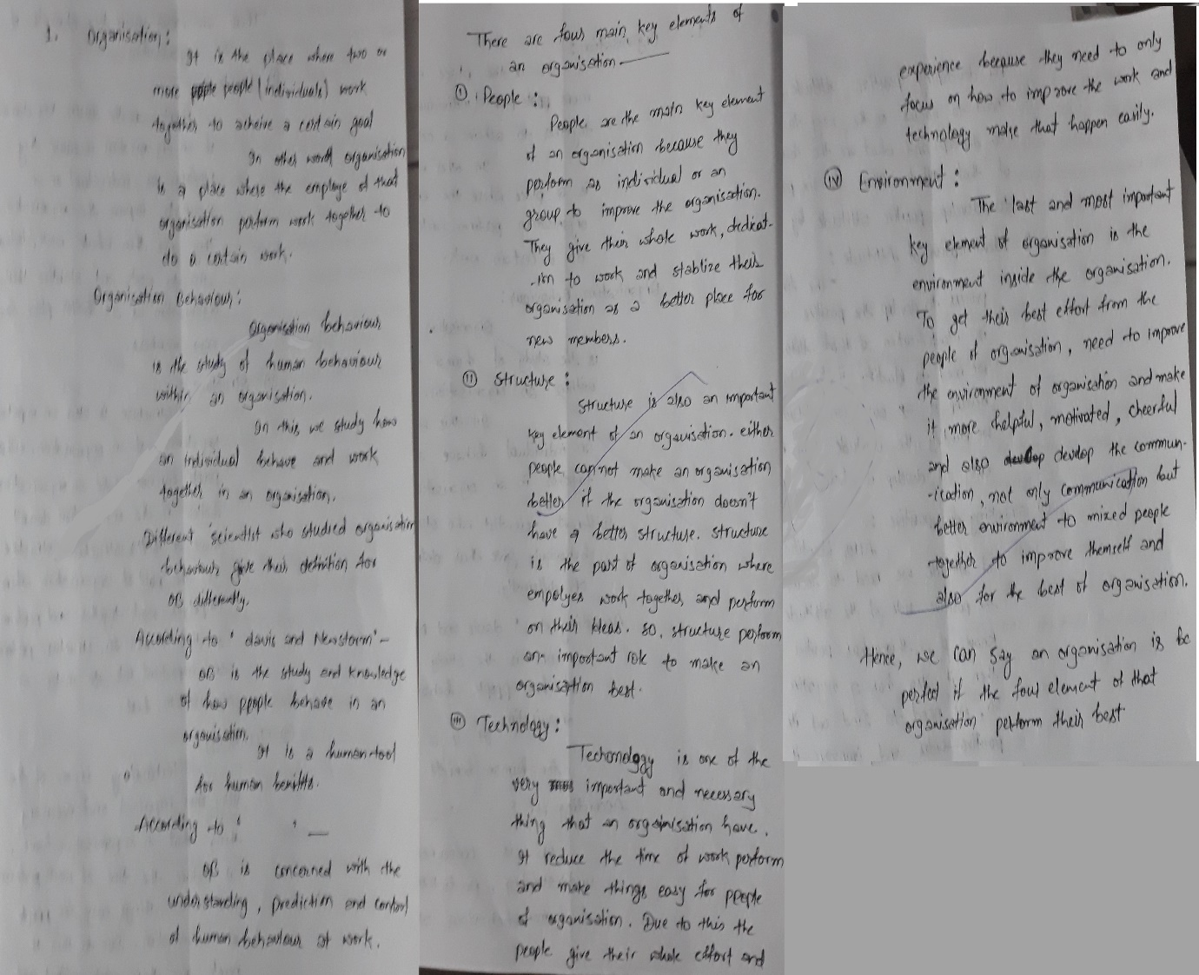

**2.**

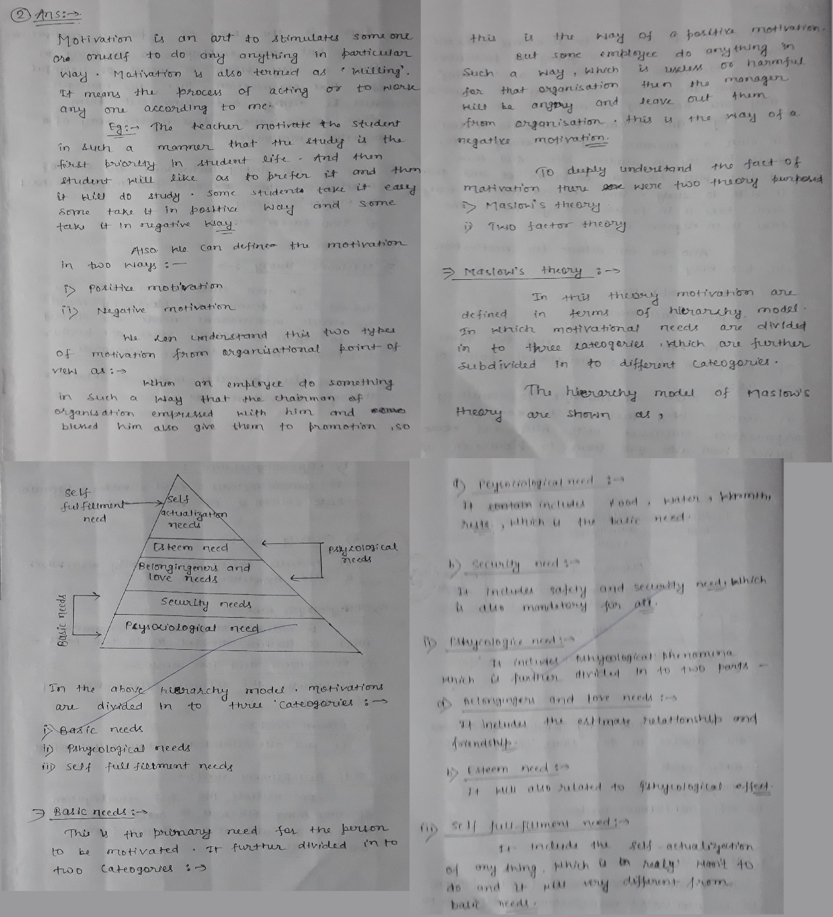

**3.**

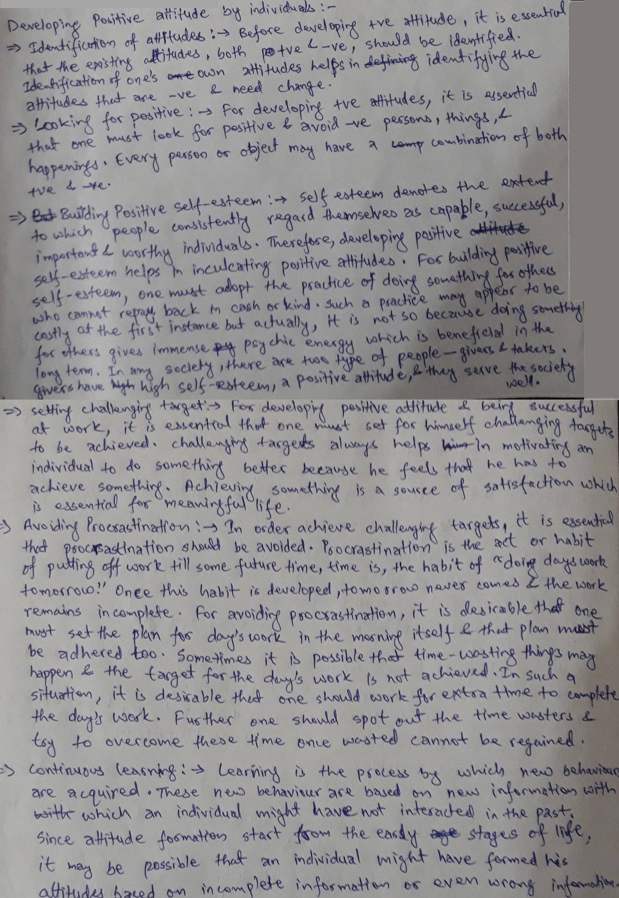**4.**

