MIT MUZAFFARPUR
COURSE FILE OF
LETHER PRODUCT TECHNOLOGY-1
(071612)
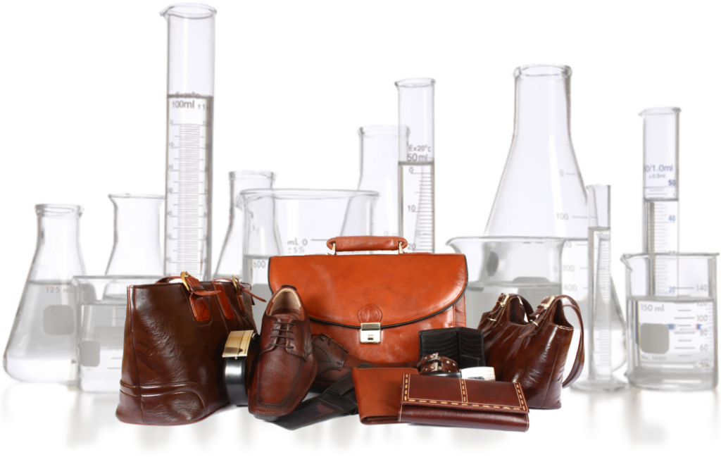

Faculty Name:
MANIKANT KUMAR
ASSISTANT PROFESSOR, DEPARTMENT OF LEATHER TECHNOLOGY

Content

S.No. | Topic | Page No.
1 | Vision of department
2 | Mission of department
3 | PEO’s
4 | PO’s
5 | Course objectives and course outcomes(Co)
6 | Mapping of CO’s with PO’s
7 | Time table
8 | Student list
9 | Lecture plans
10 | Assignments
11 | Sessional question paper
12 | University question paper
13 | Question bank
14 | Result

VISION STATEMENT
- To emerge as a national leader in graduate level studies in all sub areas of leather field and to make significant contribution to the development of the society, industry, nation and the world.

MISSION STATEMENT
- Educate leather technology students to produce quality engineers who serve leading firms and different sectors of the industry and can work in multi-disciplinary environment to anticipate and address evolving challenges of the 21st century in tanning and footwear industry.
- Impart high performance knowledge in leather and footwear sector that are economic and environment friendly.
- To establish national leadership and provide technological support to the Indian leather industry.
- Improve fundamental knowledge of inter relationship between the built environment and natural systems.

PROGRAMME EDUCATIONAL OBJECTIVES (PEOs):
After successful completion of program, graduates will be able to
PEO1: Work in the Leather and chemical and footwear field.
PEO2: Pursue higher studies.
PEO3: Contribute in teaching, research and other developmental activities of Leather technology and its allied fields.
PEO4: Work in the multicultural and multidisciplinary groups for the sustainable development and growth of leather industry projects and profession.

PROGRAMME OUTCOMES (PO):
Students who complete the B.E. degree in leather technology will be able to:
- An ability to apply knowledge of mathematics, science, and engineering,
- The ability to conduct laboratory experiments and to critically analyze and interpret experimental data.
- The ability to perform design in leather by means of design experiences integrated throughout the professional component of the curriculum.
- An ability to function on teams, that must integrate contributions from different areas of leather technology towards the solution of multi-disciplinary projects.
- An ability to identify, formulate, and solve Leather industries problems.
- An understanding of professional practice issues in leather technology including professional and ethical responsibility.
- An ability to write and speak effectively.
- The broad education necessary to understand the impact of leather fields solutions in a global and societal context.
- A recognition of the need for, and an ability to engage in life-long learning,
- An ability to use the techniques, skills, and modern tools necessary for leather technology practices.
- Possess a thorough understanding of techniques that are appropriate to environment and country.
- Possess ability to estimate costs, estimate quantities and evaluate materials for leather manufacturing.

COURSE OBJECTIVE AND COURSE OUTCOMES:
Institute / College Name : | MUZAFFARPUR INSTITUTE OF TECHNOLOGY
Program Name | B. Tech.Leather Technology
COURSE CODE | 071612
COURSE NAME | LEATHER PRODUCT TECHNOLOGY-I
Lecture / Tutorial / Practical (per week): | 3 – 0- 3 | Course Credits | 3
Course Coordinator Name | MANIKANT KUMAR

Course objective:
The objective of this course is to have a clear concept of anatomy of human footwear, last, shoe sizes and fittings and the designing procedure and the knowledge of footwear material and costing which have a wide use in leather industry, shoe industry and their allied fields.
Course outcomes (CO):
CO1: To understand the anatomy of foot for design process
CO2: To understand the last, shoe size and fitting and different footwear material.
CO3: To understand the basic designing procedure.
CO4: To develop his ability to design the shoe standard .

MAPPING OF COs AND POs
CO/PO | PO1 | PO2 | PO3 | PO4 | PO5 | PO6 | PO7 | PO8 | PO9 | PO10 | PO11 | PO12
CO1 | 3 | 2 | 2 | 1 | 2 | 1 | 1 | 1 | 2 | 1 | 1 | 1
CO2 | 3 | 1 | 2 | 1 | 2 | 1 | 1 | 1 | 2 | 1 | 1 | 2
CO3 | 3 | 2 | 1 | 1 | 2 | 1 | 1 | 1 | 2 | 1 | 1 | 2
CO4 | 3 | 1 | 1 | 1 | 2 | 1 | 1 | 1 | 2 | 1 | 1 | 3
Correlation level: 1- slight (Low) 2- moderate (Medium) 3-substantial (High)

COURSE SYLLABUS:
Topics | Number of Lectures | Weightage (%)
1.Introduction  History of Footwear industry, Functions of footwear, Different parts of Footwear (Upper, Bottom and hidden components) | 5 | 12
2. Anatomy of Human foot  Bones, Joints, Muscles, Ligaments, arches of skin of human foot, Internal and external changesof human foot from infant to adult stage, Analysis of human locomotion, Common foot abnormalities and their remedies. Foot comfort and foot care. | 7 | 16
3. Last Definition, Classification of last, Different parts of last, Seasoning of wood for wooden last, Last measurement, Comparison of last with human foot. | 4 | 10
4. Shoe Sizes and Fittings Relation between foot sizes and fittings and shoe, sizes and fittings, English, American, French, Continental and mondopoint shoe sizes and fittings system. | 3 | 10
5. Designing  Introduction, Classification of Basic design, Elements of Design, Elements of Fashion design procedure, Concept of inside form, outside form and mean form, Making a basic shoe standard, pattern making allowances, Grading (Grading m/c) | 10 | 20
6. Footwear materia.  (a) Upper and Lining materials –Different natural and synthetic materials.  (b) Adhesive –Definition, Different types of adhesives use in footwear industry and their relative advantages and disadvantages.  (c) Sole, Insole, Toe, PUA, Shonic, Stiffner, Itec, Thread, Required properties of these materials, Different types of these materials. | 9 | 20
7. Footwear Costing Material, Labour and Overhead cost, Determining the material consumption, Leather consumption –One pair tracing insole consumption, Adhesive and thread consumption etc. | 4 | 12
Total no. of lectures/weightage | 42 | 100 %

MUZAFFARPUR INSTITUTE OF TECHNOLOGY
B.Tech. 7th Semester (2015 Batch) PROVISIONAL TIME TABLE WITH EFFECT FROM 10.07.2018
^{7th}SEMESTER Leather technology ROOM NO. LB-1
 | 9:00 - 10:00 | 10:00 - 11:00 | 11:00 – 12:00 | 12:00 – 1: 00 | 1:00 – 2:00 | 2:00- 3:00 |  | 3:00 - 4:00 |  | 4:00 – 5:00
MON |  |  |  |  | R  E  C  E  S  S
TUES
WED
THUR
FRI
SAT
FACULTY NAME: MK: MANIKANT KUMAR
PAPER NAME: LEATHER PRODUCT TECHNOLOGY-1

STUDENTS LIST:

SL.  NO. | ROLL NO. | AKU REG.NO. | NAME
1 | 16LT08 | 16107107001 | ARCHANA KUMARI
2 | 16LT20 | 16107107003 | RAVINDRA RAM
3 | 16LT15 | 16107107004 | SURBHI SAURAV
4 | 16LT11 | 16107107005 | AMAN SHRIVASTAVA
5 | 16LT05 | 16107107007 | VIKASH KUMAR
6 | 16LT19 | 16107107008 | DEEPSHI
7 | 16LT16 | 16107107009 | RAKESH KUMAR SAH
8 | 16LT14 | 16107107010 | RAKESH KUMAR
9 | 16LT17 | 16107107011 | KRITIKA VAGMI

NAME LIST OF B.TECH 2017 BATCH
LEATHER TECHNOLOGY BRANCH

SL. NO. | ROLL NO. | AKU REG. NO. | NAME
1 | 17LT15 | 17107107002 | VISHWAJEET KUMAR
2 | 17LT14 | 17107107003 | ADITYA RAJ
3 | 17LT16 | 17107107005 | VIJAYA BHARTI
4 | 17LT10 | 17107107006 | SHAGUFTA FATIMA
5 | 17LT13 | 17107107007 | ABHILASHA KUMARI
6 | 17LT11 | 17107107008 | RAGINI SWARAJ
7 | 17LT17 | 17107107009 | ABHISHEK KUMAR
8 | 17LT08 | 17107107010 | ABHISHEK AMAN
9 | 17LT18 | 17107107011 | ABHAY KUMAR
10 | 18 LE LT(01) | 1710710700 | VIKASH KUMAR

Text Books:
TB1:. Physical Testing of Leather by S.S.Dutta

COURSE PLAN

Topic No. | Topic | No. of Lecture/ lecture no. | Text book
 | Introduction | 05 | TB1
 | History of Footwear industry, Functions of footwear, | 1-3
 | Different parts of Footwear (Upper, Bottom and hidden components) | 3-5
2. | 2. Anatomy of Human foot | 07
 | Bones, Joints, Muscles, Ligaments | 6-7
 | arches of skin of human foot, Internal and external changesof human foot from infant to adult stage, | 8-10
 | Analysis of human locomotion, Common foot abnormalities and their remedies. Foot comfort and foot care. | 10-12
3. | Last | 04 | TB1
 | Definition, Classification of last, Different parts of last, Seasoning of wood for wooden last, Last measurement, Comparison of last with human foot. | 9-10
4. | Shoe Sizes and Fittings | 02
 | Relation between foot sizes and fittings and shoe, sizes and fittings, English, American, French, Continental and mondopoint shoe sizes and fittings system. | 05
 |  | 13-15
 |  | 15-17
5. | Designing | 02 | TB1
 | Introduction, Classification of Basic design, Elements of Design, Elements of Fashion design procedure, Concept of inside form, outside form and mean form, Making a basic shoe standard, pattern making allowances, Grading (Grading m/c) | 18-19
6. | Footwear materia. | 05 | TB1
 | (a) Upper and Lining materials –Different natural and synthetic materials.  (b) Adhesive –Definition, Different types of adhesives use in footwear industry and their relative advantages and disadvantages.  (c) Sole, Insole, Toe, PUA, Shonic, Stiffner, Itec, Thread, Required properties of these materials, Different types of these materials. | 20-22
7. | Footwear Costing | 22-24
 | Material, Labour and Overhead cost, Determining the material consumption, Leather consumption –One pair tracing insole consumption, Adhesive and thread consumption etc.
 |  | 4 | TB1
 |  | 25-28
 | Total Number of Lectures | 41

DETAILS OF ASSIGNMENTS
S.No. | Assignment | Topic No.
1 | Assignment 1 | 1,2
2 | Assignment 2 | 3
3 | Assignment 3 | 4
4 | Assignment 4 | 5,6

END SEMESTER QUESTION PAPER
