MIT MUZAFFARPUR
COURSE FILE OF
LETHER PRODUCT TECHNOLOGY-3
(071825)
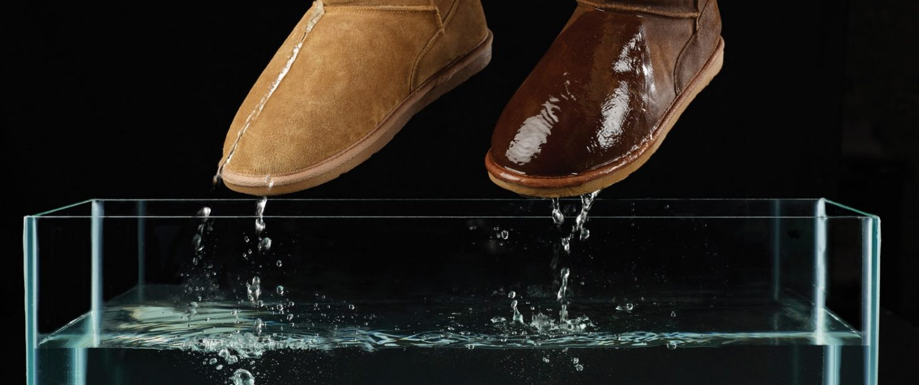

Faculty Name:
MANIKANT KUMAR
ASSISTANT PROFESSOR, DEPARTMENT OF LEATHER TECHNOLOGY

Content

 | S.No. | Topic |  |  | Page No.
- Cover page & content
- Vision and mission of institute
 | - Vision and Mission of department
- Program educational objectives (PEO’s)
- Program specific oucomes (PSO’s)
 | - Program outcomes (PO’s)
- Course objectives and course outcomes(CO’s)
 | - Mapping of CO’s with PO’s
- Time table
- Academic calendar
 | - Student list
- Lecture plans
- Weekly test papers
 | - Assignments
 | - Mid semester/Sessional question papers
 | - End semester /University question paper
- Question bank
- Reference materials
 | - Result

VISION STATEMENT
- To emerge as a national leader in graduate level studies in all sub areas of leather field and to make significant contribution to the development of the society, industry, nation and the world.

MISSION STATEMENT
- Educate leather technology students to produce quality engineers who serve leading firms and different sectors of the industry and can work in multi-disciplinary environment to anticipate and address evolving challenges of the 21st century in tanning and footwear industry.
- Impart high performance knowledge in leather and footwear sector that are economic and environment friendly.
- To establish national leadership and provide technological support to the Indian leather industry.
- Improve fundamental knowledge of inter relationship between the built environment and natural systems.

PROGRAMME EDUCATIONAL OBJECTIVES (PEOs):
After successful completion of program, graduates will be able to
PEO1: Work in the Leather and chemical and footwear field.
PEO2: Pursue higher studies.
PEO3: Contribute in teaching, research and other developmental activities of Leather technology and its allied fields.
PEO4: Work in the multicultural and multidisciplinary groups for the sustainable development and growth of leather industry projects and profession.

PROGRAMME OUTCOMES (PO):
Students who complete the B.E. degree in leather technology will be able to:
- An ability to apply knowledge of mathematics, science, and engineering,
- The ability to conduct laboratory experiments and to critically analyze and interpret experimental data.
- The ability to perform design in leather by means of design experiences integrated throughout the professional component of the curriculum.
- An ability to function on teams, that must integrate contributions from different areas of leather technology towards the solution of multi-disciplinary projects.
- An ability to identify, formulate, and solve Leather industries problems.
- An understanding of professional practice issues in leather technology including professional and ethical responsibility.
- An ability to write and speak effectively.
- The broad education necessary to understand the impact of leather fields solutions in a global and societal context.
- A recognition of the need for, and an ability to engage in life-long learning,
- An ability to use the techniques, skills, and modern tools necessary for leather technology practices.
- Possess a thorough understanding of techniques that are appropriate to environment and country.
- Possess ability to estimate costs, estimate quantities and evaluate materials for leather manufacturing.

COURSE OBJECTIVE AND COURSE OUTCOMES:
Institute / College Name : | MUZAFFARPUR INSTITUTE OF TECHNOLOGY
Program Name | B. Tech.Leather Technology
COURSE CODE | 071825
COURSE NAME | LEATHER PRODUCTTECHNOLOGY-III
Lecture / Tutorial / Practical (per week): | 3 – 0- 3 | Course Credits | 5
Course Coordinator Name | MANIKANT KUMAR

Course objective:
The objective of this course is to have a clear concept of anatomy of human footwear, last, shoe sizes and fittings and the designing procedure and the knowledge of footwear material and costing which have a wide use in leather industry, shoe industry and their allied fields.
Course outcomes (CO):
CO1: To enhance the knowledge about classification of Leather Goods and Garments, Selection of materials, Grading and assortment of Leathers for leather goods and garments.
CO2: Study about accessories for leather goods and garments comparison between manual and machine cutting, Maintenance of knives and tools, clicking machines mechanical
CO3: Study about Basic design development, Measurements/Sizing chart for Man, Women and Children, Adaptation of stages to basic blocks
CO4: To get knowledge in application of CAD for leather goods and garments design and production.

MAPPING OF COs AND POs
CO/PO | PO1 | PO2 | PO3 | PO4 | PO5 | PO6 | PO7 | PO8 | PO9 | PO10 | PO11 | PO12
CO1 | 3 | 2 | 2 | 1 | 1 | 2 | 1 | 1 | 1 | 1 | 2 | 1
CO2 | 2 | 1 | 1 | 1 | 1 | 1 | 1 | 1 | 1 | 1 | 1 | 1
CO3 | 2 | 2 | 2 | 1 | 1 | 1 | 1 | 2 | 2 | 1 | 1 | 1
CO4 | 3 | 1 | 2 | 1 | 3 | 1 | 1 | 1 | 1 | 1 | 1 | 1
Correlation level: 1- slight (Low) 2- moderate (Medium) 3-substantial (High)

COURSE SYLLABUS:
Topics | Number of Lectures | Weightage (%)
1.Introduction  Historical evolution of Garment and Goods styling, Seasonal cultural and geographical influences on fashion, Friends in fashion concept, Colour and human psychology. | 05 | 16
2 Classification of Leather Goods and Garments, Selection of materials, Grading and assortment of Leathers for leather goods and garments. Property requirement for leather and lining materials. Accessories for leather goods and garments comparison between manual and machine cutting, Maintenance of knives and tools, clicking machines mechanical, Hydraulic/Pneumatic pattern interlocking/nesting for material optimization Assembly and sticking (Closing). | 09 | 28
3 Different types of sewing machines (Flat bed, inclined bed, special type machines), Feed mechanisms, Various types of assembly techniques for leather goods and garments. | 9 | 28
4 Pattern Designing  Basic design development,Measurements/Sizing chart for Man, Women and Children, Adaptation of stages to basic blocks. Pattern development, grading. Application of CAD for leather goods and garments design and production. Feasibility reports for leather goods and garments production. Machinery requirement/plant layout, process scheduling and line balancing, Quality control measures. Packaging methods and practices. Costing, pricing and marketing procedures for domestic and international markets. | 9 | 28
Total no. of lectures/weightage | 32 | 100 %

Text Books:
TB1:. Physical Testing of Leather by S.S.Dutta

COURSE PLAN

Topic No. | Topic | No. of Lecture/ lecture no. | Text book
 | Introduction | 05 | TB1
 | Historical evolution of Garment and Goods styling, | 1-2
 | Seasonal cultural and geographical influences on fashion. | 2-4
 | Friends in fashion concept, Colour and human psychology. | 4-5
2. |  | 09
 | Classification of Leather Goods and Garments, Selection of materials. | 6-8
 | Grading and assortment of Leathers for leather goods and garments. | 9-10
 | Property requirement for leather and lining materials. | 11-12
 | Accessories for leather goods and garments. comparison between manual and machine cutting. | 12-13
 | Maintenance of knives and tools, clicking machines mechanical, Hydraulic/Pneumatic pattern interlocking/nesting for material optimization Assembly and sticking (Closing). | 13-14
3. |  | 09 | TB1
 | Different types of sewing machines (Flat bed, inclined bed, special type machines), Feed mechanisms. | 15-19
 | Various types of assembly techniques for leather goods and garments. | 20-22
4 |  | 09
 | Basic design development, Measurements/Sizing chart for Man, Women and Children, | 23-24
 | Adaptation of stages to basic blocks. Pattern development, grading. | 24-25
 | Application of CAD for leather goods and garments design and production. | 25-27 | TB1
 | Feasibility reports for leather goods and garments production. | 27-28
 | Machinery requirement/plant layout, process scheduling and line balancing, | 28-29
 | Quality control measures. Packaging methods and practices. | 30-31
 | Costing, pricing and marketing procedures for domestic and international markets. | 31-32
 | Total Number of Lectures | 32

DETAILS OF ASSIGNMENTS
S.No. | Assignment | Topic No.
1 | Assignment 1 | 1,2
2 | Assignment 2 | 3
3 | Assignment 3 | 4
4 | Assignment 4 | 5,6

ASSIGNMENT 1
Leather product technology-III
1. Discuss Fashion. Write on the seasonal, cultural and geographical influence in fashion.
ASSIGNMENT 2
1. Discuss the marketing procedure for domestic and international markets for leather goods and garment.
2. Discuss different material used in leather goods and garments manufacture.

ASSIGNMENT 3

1. Explain the dufferent types of sewing machine.
2. what is clicking? explain the types of clicking

ASSIGNMENT 4
1. What do you mean by grading and assortment of leather?
2. explain different types of grade.

END SEMESTER QUESTION PAPER
