MIT MUZAFFARPUR
COURSE FILE OF
PRACTICES OF LEATHER MANUFACTURING-III
(071824)
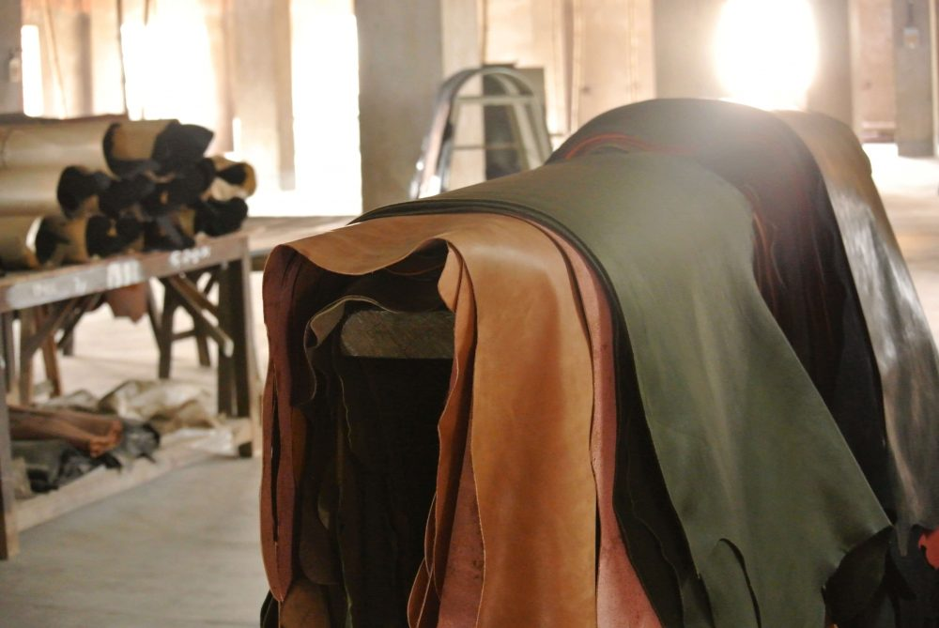

Faculty Name:
MANIKANT KUMAR
ASSISTANT PROFESSOR, DEPARTMENT OF LEATHER TECHNOLOGY

Content

 | S.No. | Topic |  |  | Page No.
- Cover page & content
- Vision and mission of institute
 | - Vision and Mission of department
- Program educational objectives (PEO’s)
- Program specific oucomes (PSO’s)
 | - Program outcomes (PO’s)
- Course objectives and course outcomes(CO’s)
 | - Mapping of CO’s with PO’s
- Time table
- Academic calendar
 | - Student list
- Lecture plans
- Weekly test papers
 | - Assignments
 | - Mid semester/Sessional question papers
 | - End semester /University question paper
- Question bank
- Reference materials
 | - Result

VISION STATEMENT
- To emerge as a national leader in graduate level studies in all sub areas of leather field and to make significant contribution to the development of the society, industry, nation and the world.

MISSION STATEMENT
- Educate leather technology students to produce quality engineers who serve leading firms and different sectors of the industry and can work in multi-disciplinary environment to anticipate and address evolving challenges of the 21st century in tanning and footwear industry.
- Impart high performance knowledge in leather and footwear sector that are economic and environment friendly.
- To establish national leadership and provide technological support to the Indian leather industry.
- Improve fundamental knowledge of inter relationship between the built environment and natural systems.

PROGRAMME EDUCATIONAL OBJECTIVES (PEOs):
After successful completion of program, graduates will be able to
PEO1: Work in the Leather and chemical and footwear field.
PEO2: Pursue higher studies.
PEO3: Contribute in teaching, research and other developmental activities of Leather technology and its allied fields.
PEO4: Work in the multicultural and multidisciplinary groups for the sustainable development and growth of leather industry projects and profession.

PROGRAMME OUTCOMES (PO):
Students who complete the B.E. degree in leather technology will be able to:
- An ability to apply knowledge of mathematics, science, and engineering,
- The ability to conduct laboratory experiments and to critically analyze and interpret experimental data.
- The ability to perform design in leather by means of design experiences integrated throughout the professional component of the curriculum.
- An ability to function on teams, that must integrate contributions from different areas of leather technology towards the solution of multi-disciplinary projects.
- An ability to identify, formulate, and solve Leather industries problems.
- An understanding of professional practice issues in leather technology including professional and ethical responsibility.
- An ability to write and speak effectively.
- The broad education necessary to understand the impact of leather fields solutions in a global and societal context.
- A recognition of the need for, and an ability to engage in life-long learning,
- An ability to use the techniques, skills, and modern tools necessary for leather technology practices.
- Possess a thorough understanding of techniques that are appropriate to environment and country.
- Possess ability to estimate costs, estimate quantities and evaluate materials for leather manufacturing.

COURSE OBJECTIVE AND COURSE OUTCOMES:
Institute / College Name : | MUZAFFARPUR INSTITUTE OF TECHNOLOGY
Program Name | B. Tech.Leather Technology
COURSE CODE | 071824
COURSE NAME | PRACTICES OF LEATHER MANUFACTURING-III
Lecture / Tutorial / Practical (per week): | 3 – 0- 3 | Course Credits | 5
Course Coordinator Name | MANIKANT KUMAR

Course objective:
The objective of this course is to have a clear concept of anatomy of human footwear, last, shoe sizes and fittings and the designing procedure and the knowledge of footwear material and costing which have a wide use in leather industry, shoe industry and their allied fields.
Course outcomes (CO):
CO1: To get ability to processing of goat glaze upper leather
CO2: To get knowledge for processing of Burton printed safety upper leather and semi chrome goat suede garment leather.
CO3: Understanding about processing of oil pull up leather and Processing of glove leather.
CO4: Ability to get recipe of different leather like Combination tanning, Embossing, Grain correction, Special effects by spray, Screen printing,

MAPPING OF COs AND POs
CO/PO | PO1 | PO2 | PO3 | PO4 | PO5 | PO6 | PO7 | PO8 | PO9 | PO10 | PO11 | PO12
CO1 | 3 | 2 | 2 | 2 | 1 | 1 | 1 | 1 | 1 | 1 | 1 | 1
CO2 | 3 | 1 | 3 | 1 | 1 | 1 | 1 | 1 | 1 | 1 | 1 | 1
CO3 | 3 | 3 | 2 | 2 | 1 | 1 | 1 | 1 | 1 | 1 | 1 | 1
CO4 | 2 | 3 | 2 | 2 | 1 | 1 | 1 | 1 | 1 | 1 | 1 | 2
Correlation level: 1- slight (Low) 2- moderate (Medium) 3-substantial (High)

COURSE SYLLABUS:
Topics | Number of Lectures | Weightage (%)
1. INTRODUCTION.  General practices and techniques involved in manufacture of different types of light leathers. | 02 | 05
2.  Glove kin, Resin upper, Glazed uppers, Lining leathers, Shoe suedes, Garment Swedes, Grain garment leathers, Gloving leathers. | 10 | 24
3. Sheep nappa, Suede garments, Uppers and safety uppers, Lining and diaphragm leathers. | 10 | 24
4. Nubuck, Oil pull up leathers, Dressing of for skins and processing of reptiles. | 10 | 24
5. Combination tanning, Embossing, Grain correction, Special effects by spray, Screen printing, Roller coating, Gravure printing, tie and dye leathers, imitation leathers. | 10 | 23
Total no. of lectures/weightage | 42 | 100 %

MUZAFFARPUR INSTITUTE OF TECHNOLOGY
B.Tech. 8TH Semester (2016 Batch) PROVISIONAL TIME TABLE WITH EFFECT FROM 06.01.2020
^{7th}SEMESTER Leather technology ROOM NO. LB-1
 | 9:00 - 10:00 | 10:00 - 11:00 | 11:00 – 12:00 | 12:00 – 1: 00 | 1:00 – 2:00 | 2:00- 3:00 |  | 3:00 - 4:00 |  | 4:00 – 5:00
MON |  |  |  |  | R  E  C  E  S  S
TUES
WED
THUR
FRI
SAT
FACULTY NAME: MK: MANIKANT KUMAR
PAPER NAME: LEATHER PRODUCT TECHNOLOGY-III

STUDENTS LIST:

SL.  NO. | ROLL NO. | AKU REG.NO. | NAME
1 | 16LT08 | 16107107001 | ARCHANA KUMARI
2 | 16LT20 | 16107107003 | RAVINDRA RAM
3 | 16LT15 | 16107107004 | SURBHI SAURAV
4 | 16LT11 | 16107107005 | AMAN SHRIVASTAVA
5 | 16LT05 | 16107107007 | VIKASH KUMAR
6 | 16LT19 | 16107107008 | DEEPSHI
7 | 16LT16 | 16107107009 | RAKESH KUMAR SAH
8 | 16LT14 | 16107107010 | RAKESH KUMAR
9 | 16LT17 | 16107107011 | KRITIKA VAGMI

NAME LIST OF B.TECH 2017 BATCH
LEATHER TECHNOLOGY BRANCH

SL. NO. | ROLL NO. | AKU REG. NO. | NAME
1 | 17LT15 | 17107107002 | VISHWAJEET KUMAR
2 | 17LT14 | 17107107003 | ADITYA RAJ
3 | 17LT16 | 17107107005 | VIJAYA BHARTI
4 | 17LT10 | 17107107006 | SHAGUFTA FATIMA
5 | 17LT13 | 17107107007 | ABHILASHA KUMARI
6 | 17LT11 | 17107107008 | RAGINI SWARAJ
7 | 17LT17 | 17107107009 | ABHISHEK KUMAR
8 | 17LT08 | 17107107010 | ABHISHEK AMAN
9 | 17LT18 | 17107107011 | ABHAY KUMAR
10 | 18 LE LT(01) | 1710710700 | VIKASH KUMAR

Text Books:
TB1-. INTRODUCTION TO THE PRINCIPLES OF LEATHER MANUFACTURE BY S.S. DUTTA
TB2 -THEORY AND PRACTICES OF LEATHER MANUFACTURE BY K.T. SARKAR

COURSE PLAN

Topic No. | Topic | No. of Lecture/ lecture no. | Text book
 | Introduction | 02 | TB1
 | General practices and techniques involved in manufacture of different types of light leathers. | 1-2 | TB1
2. |  | 10 | TB2
 | Glove kin, Resin upper, Glazed uppers, Lining leathers, | 2-5 | TB2
 | Shoe suedes, Garment Swedes, | 6-8 | TB2
 | Grain garment leathers, Gloving leathers | 9-12 | TB2
3 |  | 10
 | Sheep nappa, Suede garments,. | 13-17 | TB2
 | Uppers and safety uppers, Lining and diaphragm leathers | 17-22 | TB2
4. |  | 10
 | Nubuck, Oil pull up leathers | 23-27 | TB2
 | Dressing of for skins and processing of reptiles. | 28-32 | TB2
5. |  | 10 | TB1
5. | .  Combination tanning, Embossing, Grain correction, | 33-36 | TB1
 | Special effects by spray, Screen printing, Roller coating,. | 37-39 | TB1
 | Gravure printing, tie and dye leathers, imitation leathers | 40-42 | TB1
 | Total Number of Lectures | 42

DETAILS OF ASSIGNMENTS
S.No. | Assignment | Topic No.
1 | Assignment 1 | 1,2
2 | Assignment 2 | 3
3 | Assignment 3 | 4
4 | Assignment 4 | 5,6

ASSIGNMENT 1
PRACTICES OF LEATHER MANUFACTURING-III
1. State the utility of lining leather. Explain the manufacturing process of lining leather.
2. what is oil tanning . write the method of manufacturing of chamois leather.

ASSIGNMENT 2
1. State the manufacturing process of shrunken grain leather.
2. write about the East India tanned leather.

ASSIGNMENT 3

1. what is full chrome leather.
2. write about the glace kid leather.

ASSIGNMENT 4
1. Write about the physical characteristic of glove leather.
2. Explain the properties of glazed leather.
3. Deduce a recipe to make goat glazed leather for shoe from raw material of Muzaffarpur origin.

