Name of the Institution | Muzaffarpur Institute of Technology
Address | Muzaffarpur Institute of Technology  Muzaffarpur, Bihar, India  Pin – 842003
Phone number | 0621-2262442
Email ID | principal@mitmuzaffarpur.org
Website | https://www.mitmuzaffarpur.org/
AICTE MANDATORY DISCLOSURE
MIT MUZAFFARPUR

- Institute Details

2. NAME AND ADDRESS OF THE TRUST / SOCIETY / COMPANY
Name | Department of Science Technology &  Technical Education
Organization Type | Government Body
Address | Government of Bihar, Patna
State | Bihar

3.NAME AND ADDRESS OF THE PRINCIPAL

Name | Dr. Mithilesh Kumar Jha
Qualification | Ph.D
Address | MIT Campus, Muzaffarpur
Phone | 9417290668
Email | principal@mitmuzaffarpur.org

4. Name of the affiliating University: Bihar Engineering University,Patna

5. Governance

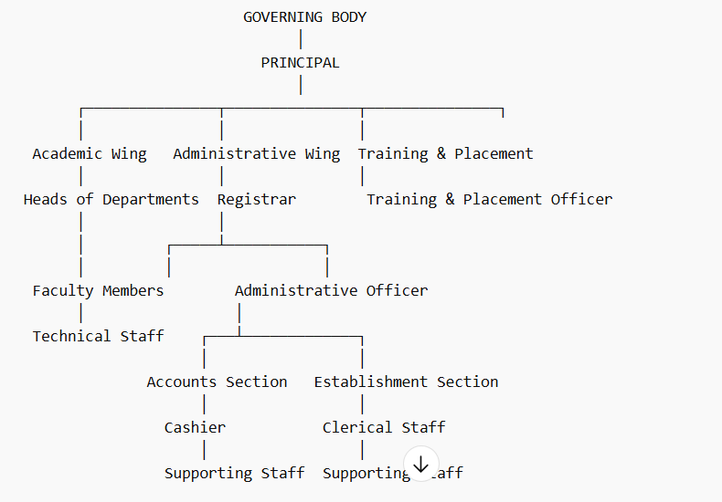
Other Units Reporting to Principal:
-----------------------------------
• Library (Librarian → Assistant Librarian → Library Staff)
• Hostel Administration (Warden → Hostel Staff)
• Examination Section
• Sports & Physical Education Department
• Student Welfare Committees

Grievance Redressal mechanism for Faculty,staff and students
class committee meetings are conducted once in a month. The faculty advisor /senior tutors arrange such meetings. An open discussion will be made and the students share out their difficulties and grievances. This is being brought to the notice of the college advisory board and redressed after discussion. Periodical faculty meetings are being conducted at the department level to give suggestions for improving the academic programmes. The respective HODS will present the various points in the college advisory board meetings. The academic issues will be sorted out and the administrative problems will be transferred to the management for solution.
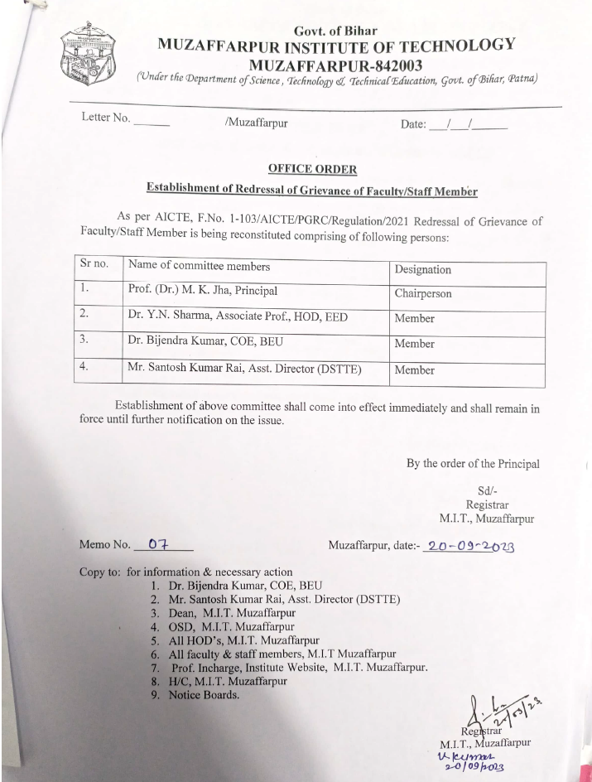
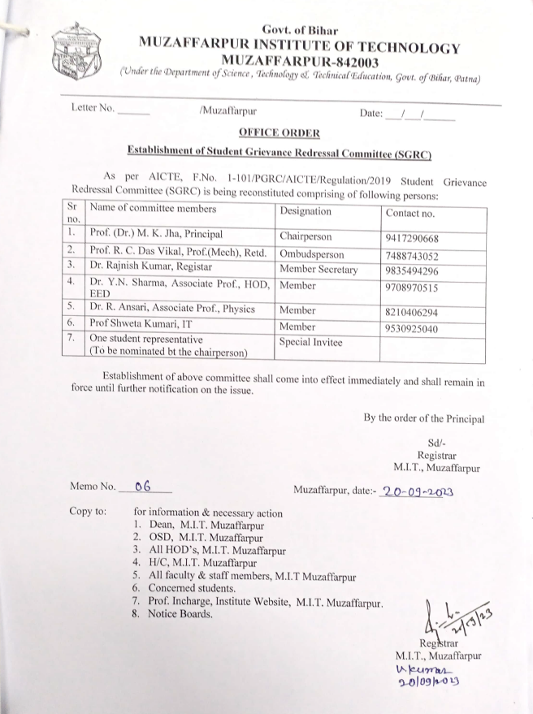

Establishment of Anti Ragging Committee / Anti Squad
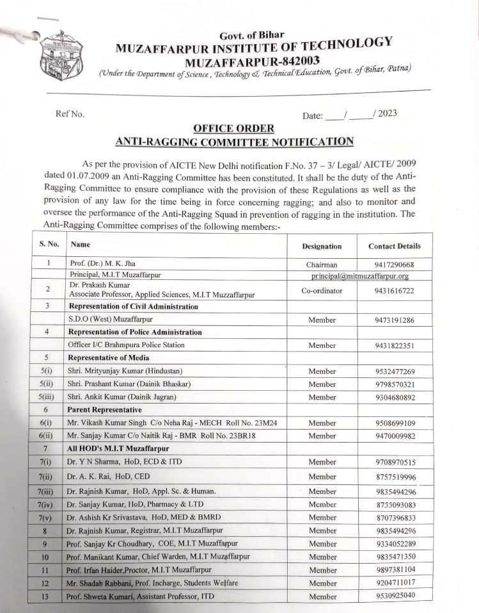
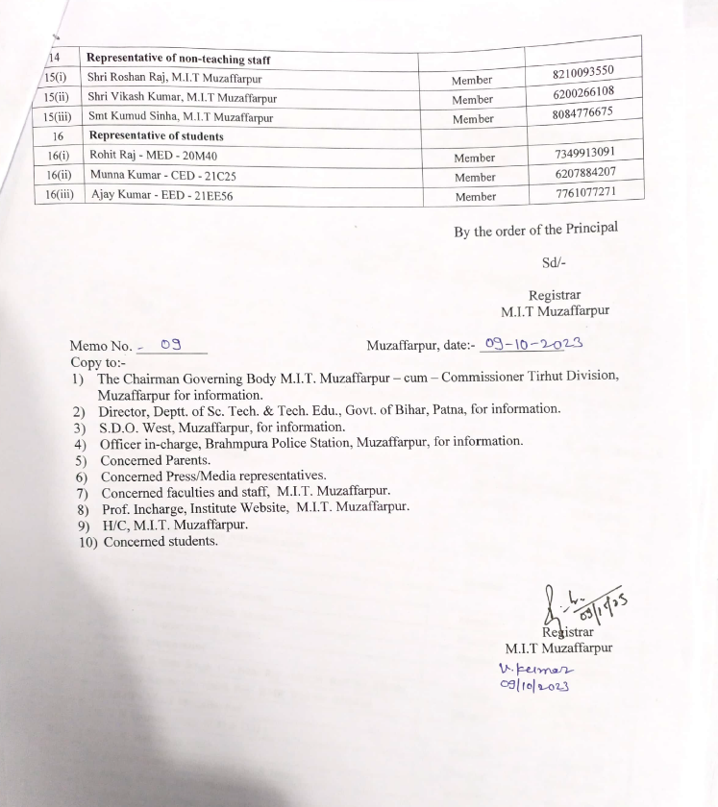

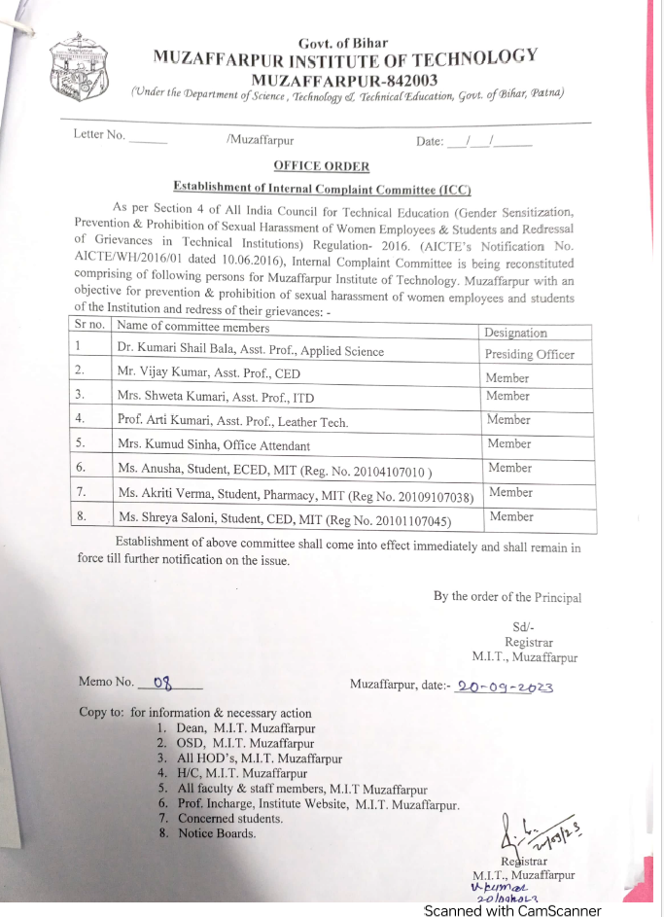
Establishment of Internal Committee(IC)
Establishment of Committee for SC/ST

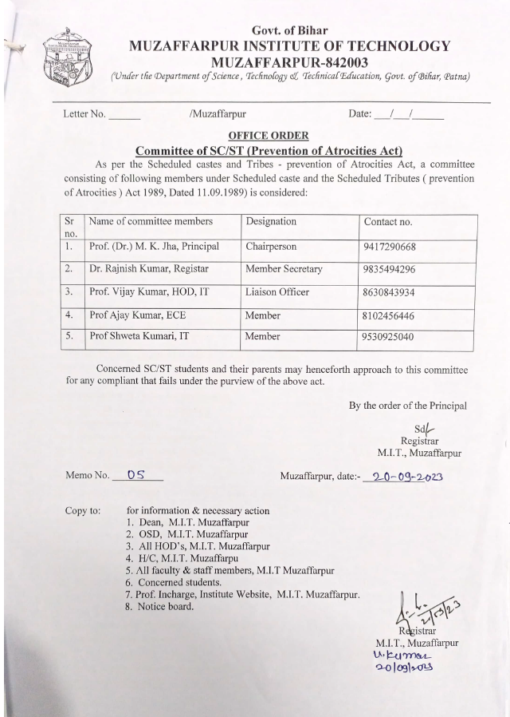
Internal Quality Assurance Cell

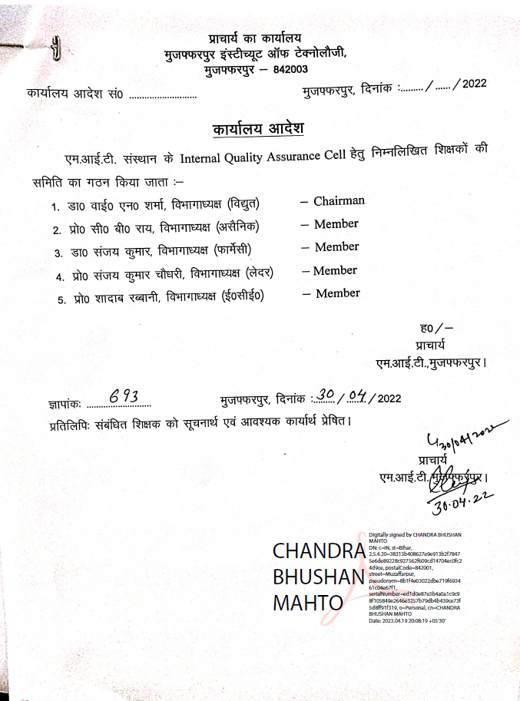

Programmes
Name of Programmes approved by AICTE
- B.Tech
- M.Tech
Name of Programmes Accredited by NBA- NIL
Status of Accreditation of the Courses-PENDING
Total number of Courses
- B.Tech - 9
- M.Tech-5
 | NAME | NO.OF SEATS | DURATION | Cut off marks/rank of admission during the last years
B.TECH | Civil Engineering | 60 | 4 Years
B.TECH | Mechanical Engineering | 60 | 4 Years
B.TECH | Biomedical and Robotics Engineering | 60 | 4 Years
B.TECH | Electronics and Communication Engineering | 60 | 4 Years
B.TECH | Electrical Engineering | 60 | 4 Years
B.TECH | Computer Science and Engineering | 60 | 4 Years
B.TECH | Information Technology | 60 | 4 Years
B.TECH | Leather Technology | 30 | 4 Years
B.TECH | Chemical Engineering | 30 | 4 Years
M.TECH

TOTAL NO OF SEATS- B.TECH-
M.TECH-
ADMISSION PROCEDURE- 1. Through JEE MAINS RANK
2 BCECE UGEAC
FEE-

FACULTY
